Industrial Load Simulation

Ian Bledsoe

December 18, 2019

# Purpose of this script is to generate loads for 800 simulated futures

Camas, Halsey, Wauna&Cogen - wauna & cogen should be covariant. Used in the DPM.

# Histograms!

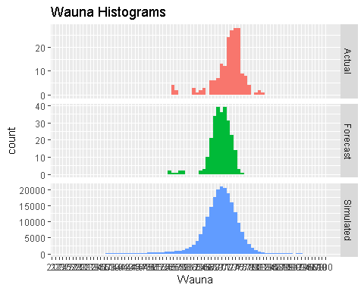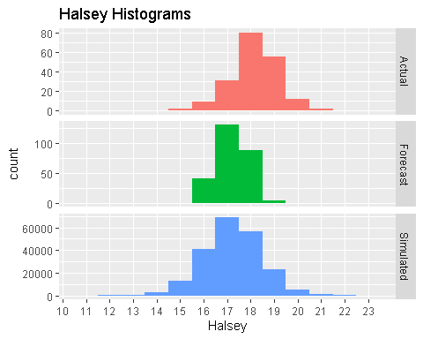

## Warning: Removed 159 rows containing non-finite values (stat_bin).

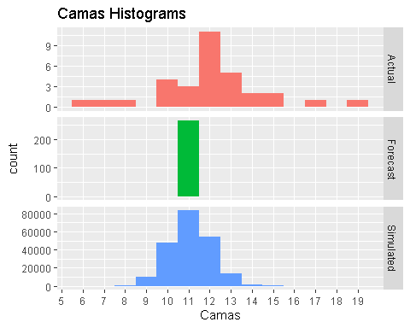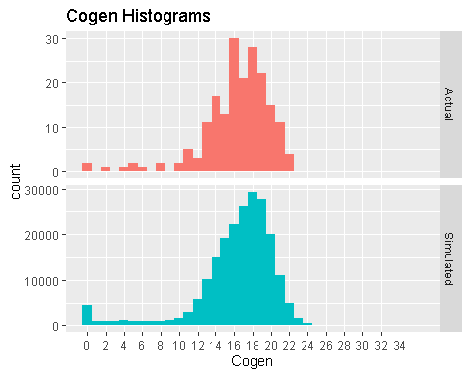

# 2d Bin Plots

## Hist. normalized Wauna:

## Min. 1st Qu. Median Mean 3rd Qu. Max.   
## 55.93 70.58 72.98 72.11 74.88 82.09

## Random Wauna:

## Min. 1st Qu. Median Mean 3rd Qu. Max.   
## 25.34 67.20 70.01 69.65 72.72 100.01

## ***************

## Hist. normalized Cogen:

## Min. 1st Qu. Median Mean 3rd Qu. Max.   
## 0.00 14.55 16.99 16.29 18.74 22.27

## Random Cogen:

## Min. 1st Qu. Median Mean 3rd Qu. Max.   
## 0.00 14.75 17.11 16.26 18.94 35.59

## ***************

## Hist. normalized Halsey:

## Min. 1st Qu. Median Mean 3rd Qu. Max.   
## 15.14 17.60 18.19 18.14 18.70 20.70

## Random Halsey:

## Min. 1st Qu. Median Mean 3rd Qu. Max.   
## 10.61 16.43 17.22 17.22 18.01 23.44

## ***************

## Hist. normalized Camas:

## Min. 1st Qu. Median Mean 3rd Qu. Max. NA's   
## 6.159 10.564 12.257 12.011 12.770 19.012 159

## Random Camas:

## Min. 1st Qu. Median Mean 3rd Qu. Max.   
## 6.797 10.427 11.074 11.074 11.721 15.583

## ***************

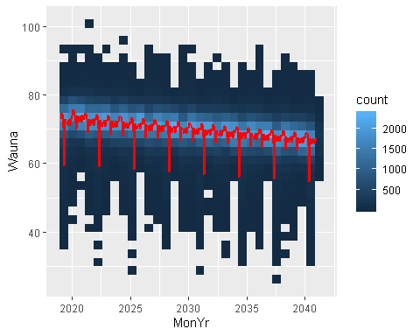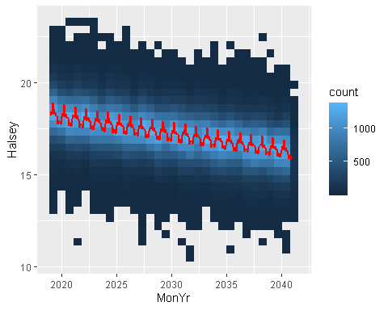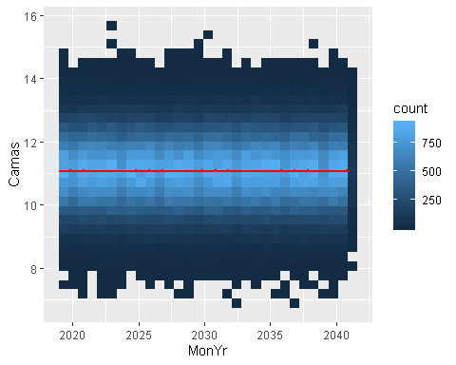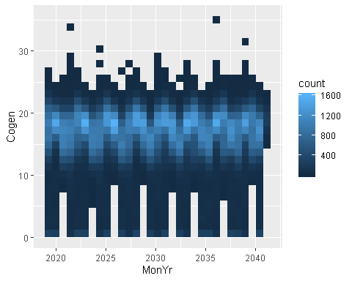

# Plot Outage Normalized

Actuals (black) & outage-normalized (red) 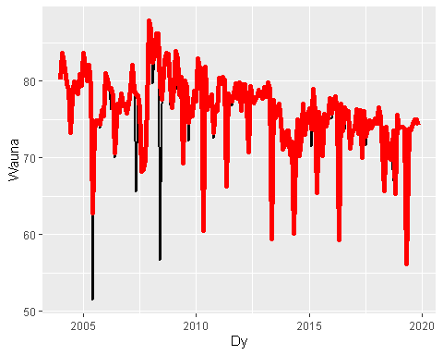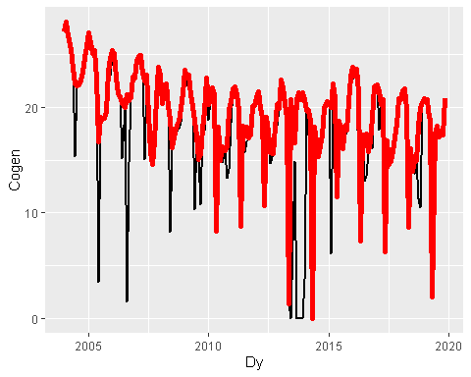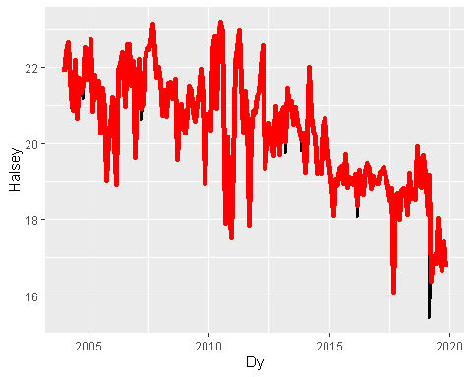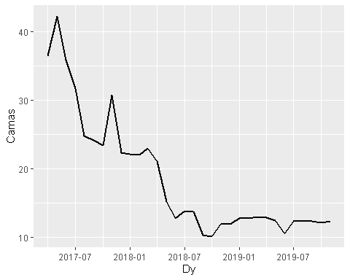

# Plot EE removed

Actuals (black), outage normalized (red), and outage normalized with ee removed (blue) 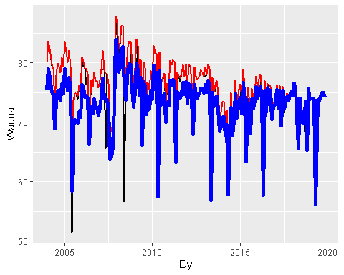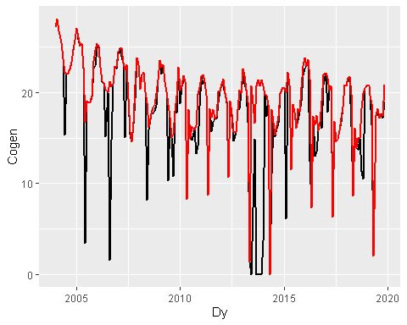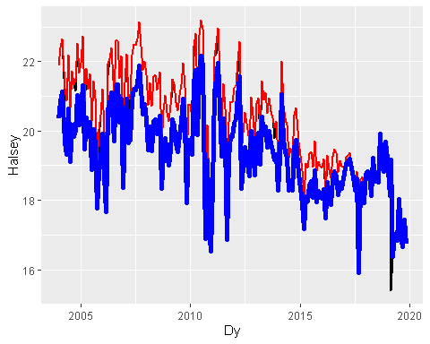

# Plot Trend Removed

Actuals (black), outage normalized (red), outage normalized with ee removed (blue), and outage normalized with ee removed and trend removed (green)

